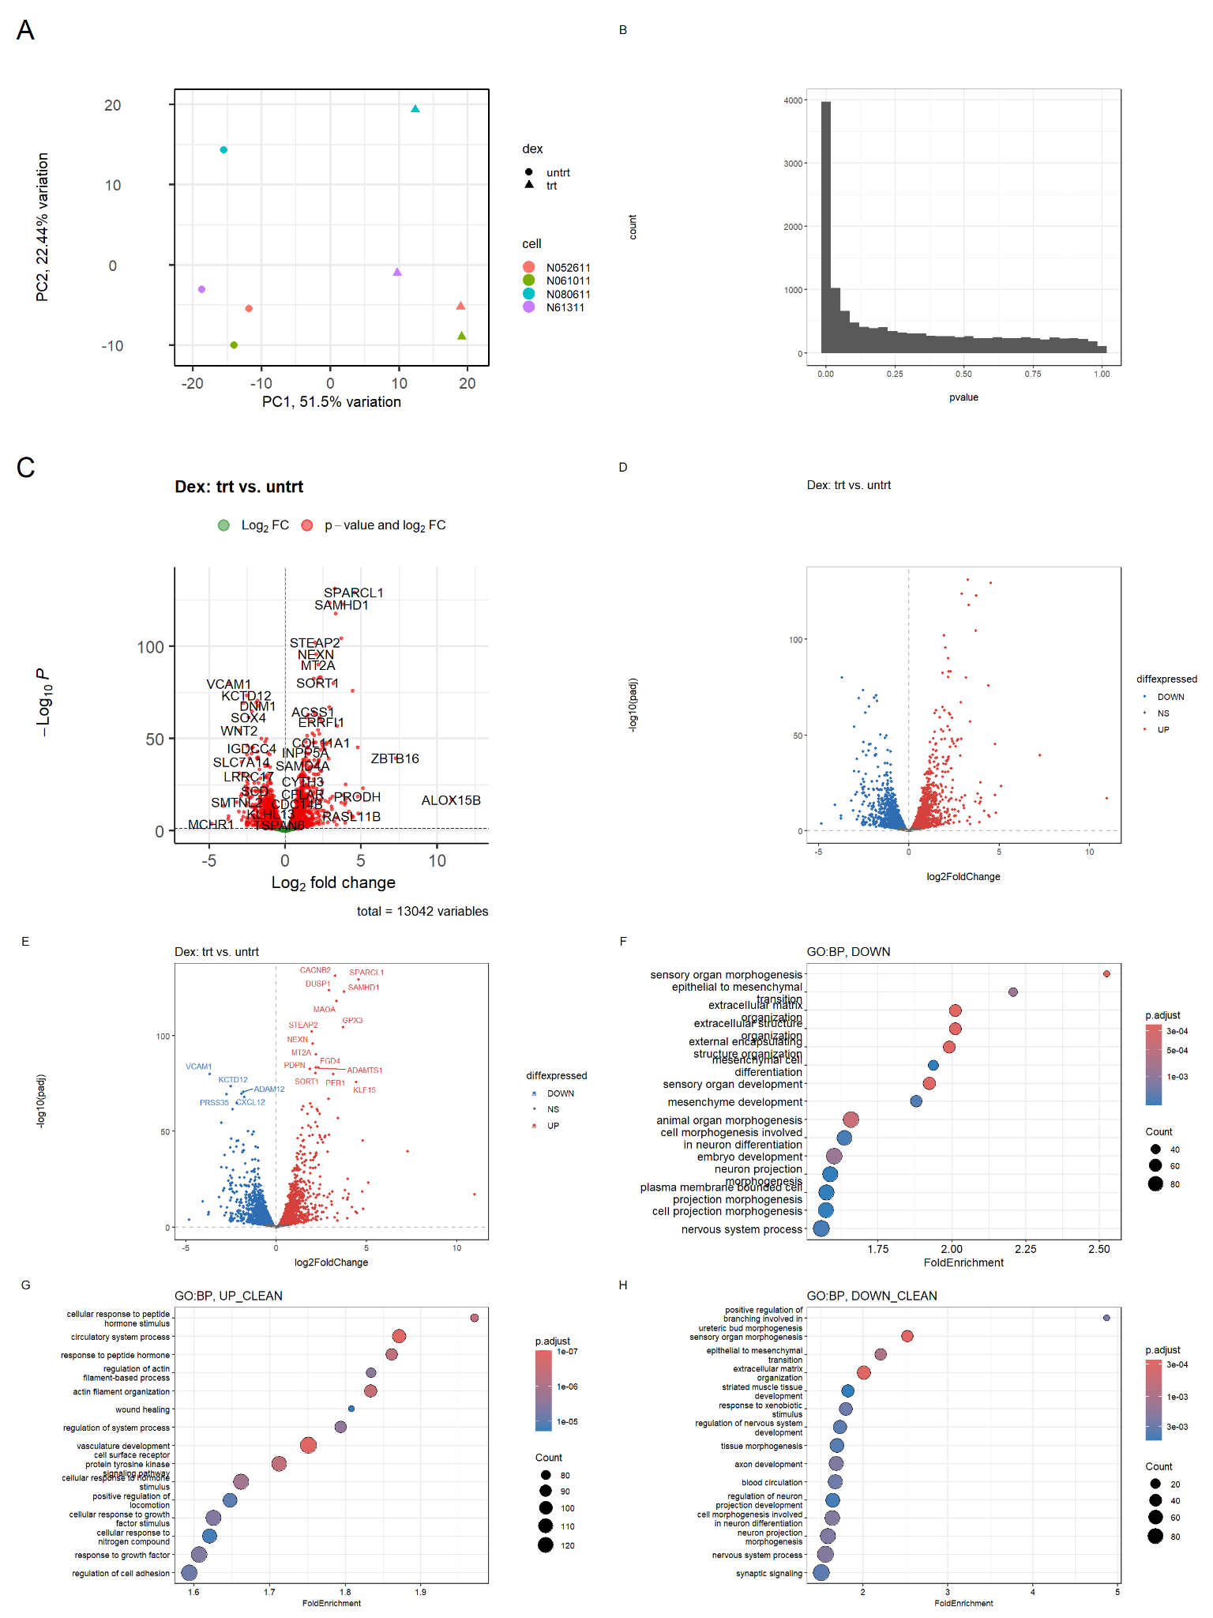

Panel A:
PCA of gene expression, using the 10% most variable genes. Each point represents one sample.
Colors -> cell lines
shapes -> dexamethasone-treated and untreated samples
Panel B:
Histogram of raw p-values from the differential expression analysis
Panel C:
Volcano plot generated with EnhancedVolcano
shrunken log2 fold changes and −log10 adjusted p-values for trt versus untrt samples
Panel D:
A custom volcano plot using an adjusted p-value threshold of 0.05
Panel E:
The custom volcano plot with labels for the 20 significant genes with the smallest adjusted p-values
Panel F:
GO Biological Process enrichment results for downregulated genes before removing redundant terms.
Panels G and H:
Clean GO Biological Process enrichment results for upregulated and downregulated genes.
The horizontal axis represents fold enrichment, dot size indicates the number of genes associated with each term, and color represents the adjusted p-value.

Observation:
In PCA, PC1 and PC2 explain 51.5% and 22.44% of the variation. The p-value histogram shows a strong concentration of small p-values. The volcano plots show significant expression changes in both directions -> dexamethasone treatment is associated with both increased and decreased expression of individual genes.
Upregulated genes: processes including responses to peptide hormones, actin filament organization, wound healing, and vasculature development.
Downregulated genes: processes including extracellular matrix organization, epithelial-to-mesenchymal transition, tissue morphogenesis, and neuronal development.
Conclusions:
We asked whether dexamethasone changes gene expression in airway smooth muscle cells. The differential expression results support this hypothesis. GO enrichment suggests that these changes involve hormone responses, cytoskeletal organization, extracellular matrix organization, and developmental processes.
evidence of a transcriptional response to dexamethasone.

